LAB 6
AIM:
Name:
Dept-Sec-Roll no.:
Registration no.:
To implement the T-test model
Mrunali Jibhakate

EE-B-107
23071350
1
. Import the required packages
2
. Create the two variable x &amp; y
3
. Assign the values to the 2 variable
4
. Find the standardization of it
5
. Print the result
6
. End the result
Steps.:
Program.:
import numpy as np
import seaborn as sns
import matplotlib.pyplot as plt
from scipy import stats
np.random.seed(42)
a = np.random.normal(80, 8, 30)
b = np.random.normal(75, 10, 30)
t_stat, p_val = stats.ttest_ind(a, b)
print(f"Analysis Results:")
print(f"{'-'*20}")
print(f"T-statistic: {t_stat:.3f}")
print(f"P-value:

{
p_val:.3f} ({'Significant' if p_val < 0.05 else
'Insignificant'})")
plt.figure(figsize=(8, 5))
sns.kdeplot(a, fill=True, color='royalblue', label='University A
(
Mean=80)'
)
sns.kdeplot(b, fill=True, color='seagreen', label='University B
(
Mean=75)'
)
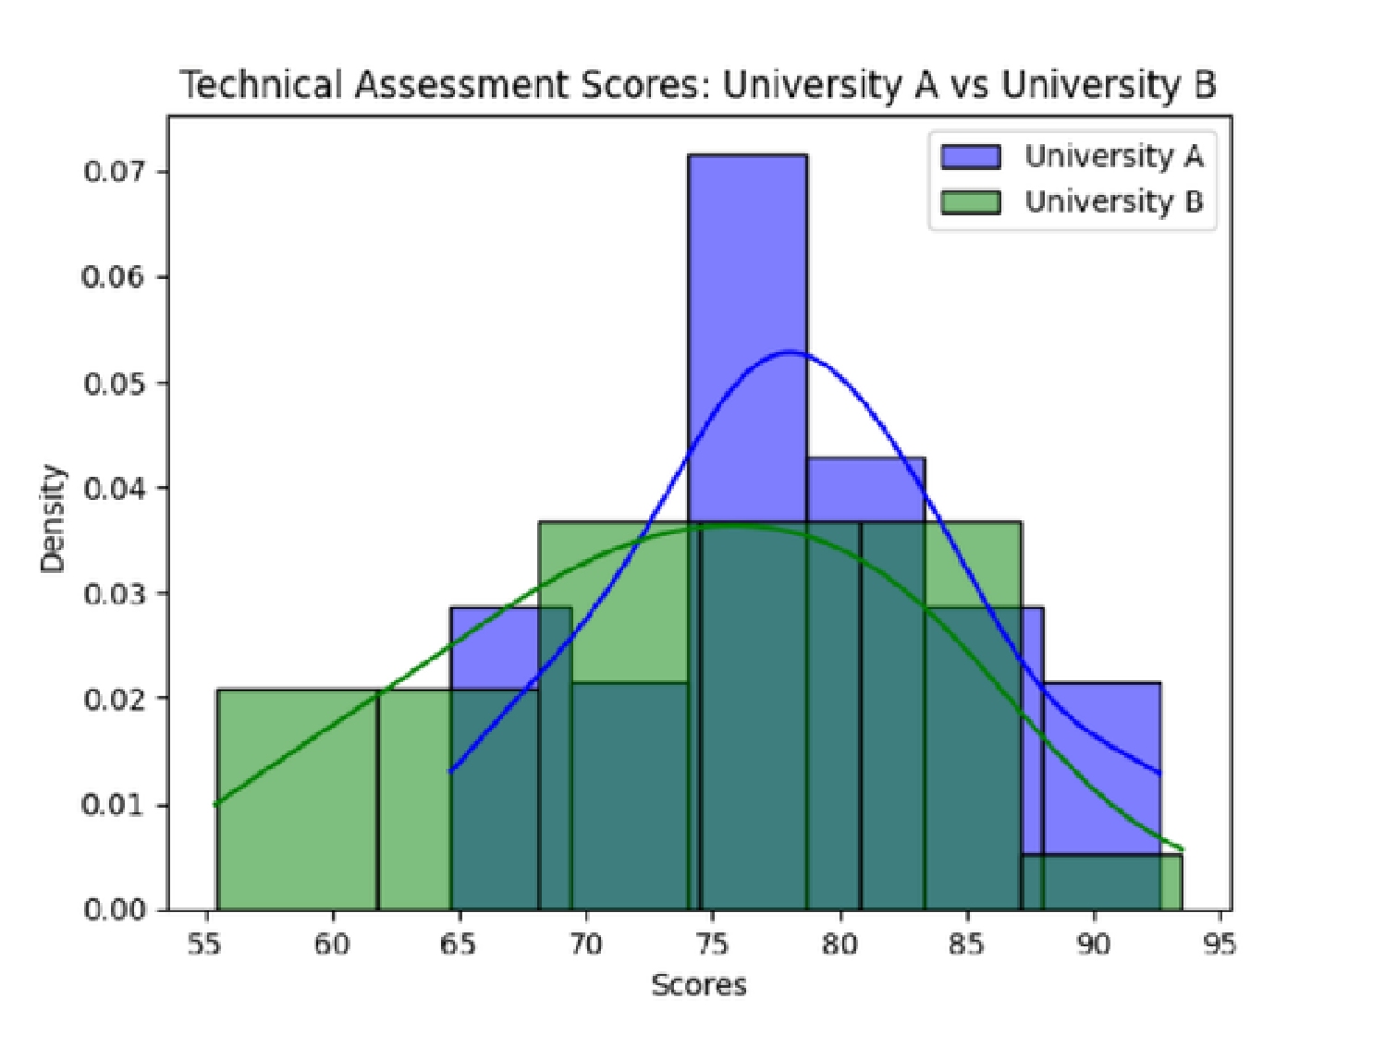
Program:
plt.title('Technical Assessment: Score Distribution Comparison', pad=15)
plt.xlabel('Assessment Score')
plt.ylabel('Density')
plt.legend()
sns.despine()
plt.tight_layout()
plt.show()
Output:

